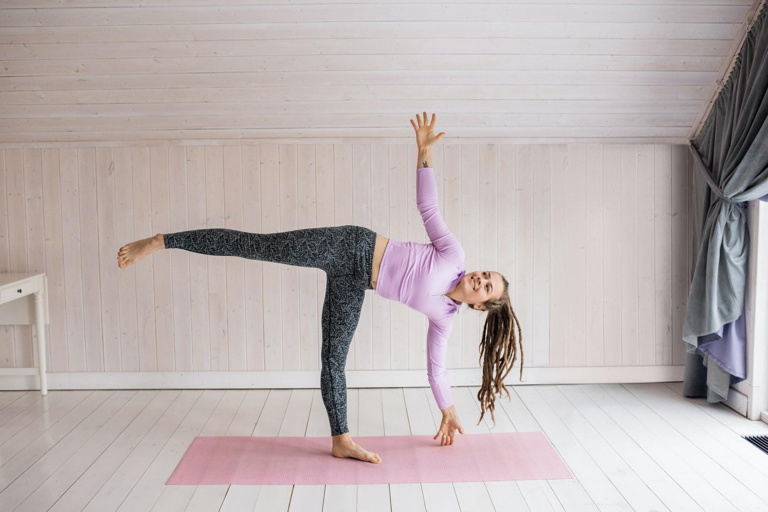

Tips and Tricks for Home Workouts During COVID-19
Whether you’ve been going to the gym for years or you just started working out regularly, the social distancing requirements and business closures due to COVID-19 likely knocked you off course. But if you’ve always thought about designing your own home gym or yoga room, you finally have the perfect excuse! We’ve gathered some great resources to help you choose the right machines and equipment for your home gym, do your favorite yoga sequences solo, and put “self-care” at the top of your to-do list during the pandemic. By the time you’re ready to return to the gym, it will be like you never hit the pause button.

Home Gym Equipment Guides

How to Pick a Good Yoga Mat
Exercise at Home With Your Home Fitness Equipment
Weight Plates Buying Guide

Home Gym Workout Ideas

Easy and Effective Dumbbell Arms, Back, and Chest Workout
The Best Core Exercises for All Levels of Gym-Goer
5 Killer Leg Day Exercises You Can Do at Home
Yoga Poses for Your Fitness Goals

9 Yoga Stretches to Increase Flexibility
7 Yoga Poses to Strengthen and Tone Your Core
10 Yoga Poses and Exercises for Balance Training

Choose the Right Athletic Wear

How to Pick the Best Workout Clothes
Choosing the Right Athletic Shoes for Your Feet
Fitness Tracker Buying Guide

Indulge in Self-Care

Satisfy Your Sweet Tooth With a Candyless Candybar
Foods Scientifically Proven to Help Ease Depression
7 Easy Ways to Create a Spa-Like Experience at Home
Vision Board 101: How to Use This Manifestation Tool
7 Great Ways to Make Your Morning Routine Easier

If in person fitness classes aren’t an option for you right now, whether by choice or closures, it’s still important to keep your goals top of mind. And while it can take some time to adjust to home workouts, once you get used to the change, you’ll learn to love exercising in your home gym. Plus, you’ll have plenty of extra time for self-care when you’re not exercising.

Photo Source: Pexels

